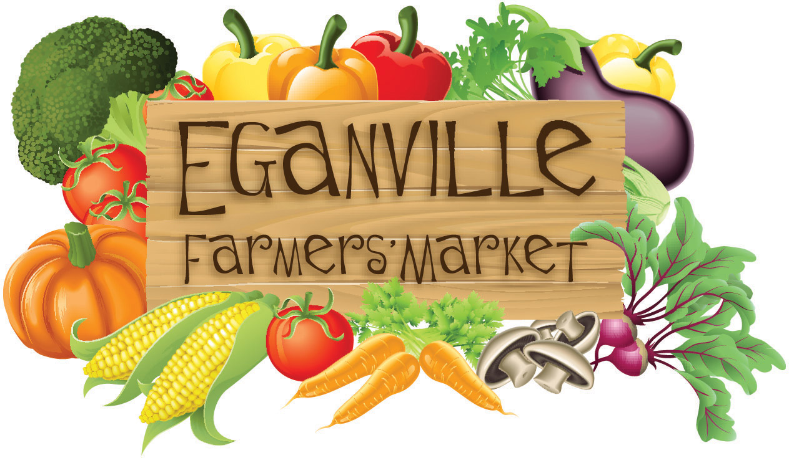

VENDOR APPLICATION
2024 SEASON

1264 Sutherland Rd, Cobden ON K0J 1K0 Tel: (613) 638-2794
e-mail: eganvillefarmersmarket1@gmail.com

All vendors wishing to participate at the Eganville Farmers' Market must complete the following information and forward it to the address above. No one may arrive and set up without completing this Application and being approved.

BUSINESS NAME: ________________________________________________

OWNED BY: _____________________________________________________
MAILING ADDRESS: ______________________________________________

POSTAL CODE: _____________________

TELEPHONE (land line): _____________________

CELL PHONE: _______________________

E-MAIL ADDRESS: _____________________________________________________

WEBSITE: ____________________________________________________________

I give permission to include the following information as part of my listing on the Eganville Farmers’ Market website (www.eganvillefarmersmarket.com)

Business Name Yes __ No __
Mailing Address Yes __ No __
Telephone/Cell Yes __ No __
Email Yes __ No __

Website or facebook page Yes __ No __

LOCATION:

Legion Memorial Field, Foran St, Eganville, ON (Across from St. James Catholic Church)

RATE AND RENTAL PERIOD:

$120 if paid before May 1 for full 2024 season (19 weeks). Payable with application.
($140 if paid on or after May 1)

Every Friday from 2:00 pm to 5:00 pm, June 7 to October 11, 2024 inclusive.

HYDRO REQUIREMENTS: YES __ NO __

Note: An additional fee of $10 per season will apply for hydro.
A limited number of stalls with electricity are available so apply early.

LIST ALL PRODUCTS YOU WISH TO SELL:

The Eganville Farmers’ Market determines what products on a vendor’s application can and cannot be sold on the market premises. Selling products not listed on your application renders your application null and void and you, as a vendor, forfeit the right to sell at this market. A request for the addition of products not listed may be submitted later in the season to the Market Committee for approval.

The Applicant acknowledges and agrees with all rules, regulations and conditions as specified on pages 3 to 5 in this Application.

Signed: _____________________________________

Date: _______________________________________

Please forward pages 1 & 2 to the address at the top of page 1 along with the applicable fee.
Keep pages 3 to 5 for your records.

RULES AND REGULATIONS

- The Eganville Farmers’ Market (EFM) is producer-based and was established to provide fresh, local items to customers and to provide an opportunity for local producers to sell their products. Vendors are strongly encouraged to use locally produced ingredients whenever possible in their products.

- Vendors may be allowed to “re-sell” products (i.e. products they did not produce) in special circumstances and only with approval from the Market Committee. This may apply in situations when products are not locally available or when products are sold for the purposes of market fundraising. The Committee will primarily consider whether or not the re-sold products help to make the EFM viable and whether products are suitable for the market.

- Your stall cannot be sublet or otherwise assigned or used by persons other than those named on the application. The person signing the application or his/her representative must be present during the rental period. Violation of this renders the vendor’s application null and void and the vendor forfeits the right to sell at this market.

All Vendors MUST notify the market organizers if they are unable to attend. This should be done as soon as possible BUT no later than 10:00 am on market day. Contact Contact : Jo Pilverdier 613-638-2794 or Email: cjpilverdier@nrtco.net

- Vendors must adhere to Municipal, Provincial and Federal Regulations regarding labeling, measures, health and safety, etc. for all products offered for sale at the market. Awareness and compliance is the responsibility of the individual vendor and not the Eganville Farmers’ Market. New regulations occur frequently – contact your governing body for updates.

- Vehicles cannot enter the market area after 1:45 pm or leave before 5:00 pm. This is a safety concern for the people visiting the market and other vendors. If a vendor has not arrived by 1:45 pm, set up is permitted but without the use of a vehicle. Caution must be exercised at all times when operating a vehicle in the area.

- All vendors are expected to be open and ready for sales at market opening time and stay until closing time. If you sell out, post a “Sorry Sold Out” sign on your table and return at the end of the market to remove your table and clean up your stall.

- Sales should not begin until the opening bell has rung. This will allow adequate time for set-up prior to the beginning of sales.

- No vendor may practice “flea market-type” pricing or offer discount pricing at the end of the day. The market is committed to supporting fair value for top-quality products all day.

- The vendor must remove all garbage or waste material on or around the rented space and the space must be left as it was on arrival. This includes scraps and trimmings from produce. The grounds should be left ready for the next user.

- Alcoholic beverages are not permitted on the grounds. Smoking is not allowed in vendor stalls.

- Live animals are not allowed in vendor stalls. Guide dogs excepted.

- All vendors will be expected to contribute some volunteer hours in a flexible manner for the betterment of the Eganville Farmers’ Market over the course of the season.

Vendors must fully comply with the Rules and Regulations as set out in this document. Vendors who do not comply with a rule will be notified in writing regarding how they are not in compliance. If 2 notices have been given and the
vendor does not comply, the third infraction will result in a letter of termination.

ADDITIONAL INFORMATION FOR VENDORS

- Shelter, tables, chairs, displays, etc. are the responsibility of the vendor. Provision to secure these items from extreme weather are also the vendor’s responsibility. There are NO blocks, spikes, ropes, etc. provided.

- A sign or banner with your name or the name of your business is recommended but not mandatory. A name tag is a good idea because customers like to get to know you.

- Insurance coverage against bodily injury and property damage to third parties is provided to vendors during Market hours by the Eganville Farmers’ Market through Farmers’ Markets Ontario. Vendors wishing to acquire additional coverage for personal property or products are encouraged to do so.

- The vendor is solely responsible for all personal loss, costs, damages and expenses of any kind whatsoever which occur due to participation in this market.

FOOD SAFETY

Every person handling food products must maintain a high standard of personal hygiene and cleanliness. All vendors must practice these standards to prevent the transfer of pathogens between vendors and foods. Please adhere to the following guidelines:

- All foods offered for sale must be protected from contamination.

- Baking and processed foods must be pre-packaged at point of production, or contained in a display case to protect from airborne and human contamination.

- All persons handling food, must wear clean clothing, wash hands often, be free from infectious disease, NOT smoke, and avoid touching nose, mouth, hair and skin. If money has been handled, hands must be washed before resuming food handling.

- All Vendors MUST wash hands thoroughly with warm water and soap after visiting the washroom.

- Containers and wrappings must be single-use only.

- Do not allow any unauthorized persons access to where food is being prepared. Watch children closely.

- All food must be at least 15 cm (6 in) off the floor/ground.

- All canned products must be packaged in sterilized jars and sealed with new vacuum lids.

- Clean up the serving area often, being especially careful to pick up food scraps that fall onto the ground or floor.

- Sampling and condiments:

- Do not allow customers to get hands anywhere near samples to be eaten by other customers.
- Prepare individual samples that cannot be handled by more than one person.
- Provide toothpicks or small paper containers or pass out each sample.
- Provide tongs, forks or spoons for each type of condiment being offered (no customer hands in the bowls).

